Jan/Feb Newsletter

(Dates for calendar)
Jan 1-breakfast Church
Jan 9-Council 4:30
Jan 10- Vision team 7pm
(Jan 15-Annual Congregational Meeting)
Jan 16-MLK day, office closed
Jan 18-Grocery Club
Jan 26-Book Group

Feb 15-Grocery Club
Feb 23-Book Group
Feb 25 Called to Lead Event

Looking Ahead: Ash Wednesday is on March 1, service at 7pm. In Lent, Pr. Mark Molter and Pr. Kelly will lead a joint “Confirmation in Review” with Community Lutheran Church. All are welcome to join us in Millsboro (location TBD) on Sunday evenings during Lent to dive deeper into Luther’s small catechism.

Our Annual Congregational meeting will be held on Sunday, January 15 following the service. We will see the annual report, discuss the budget, vote on how to proceed with the land, and elect congregational council members. Please plan to attend this important meeting.

Book group books:
January: Homegoing by Yaa Gyasi
February: My Own Words by Ruth Bader Ginsburg

Pulpit Exchange: On January 29 we welcome Pastor Mark Molter to Grace of God to preach and lead worship. Pastor Kelly will be preaching and leading worship at Community Lutheran Church that day.

Bible Study starts again on January 9!
Monday Morning Bible Study (11am, Ocean Grill)-Looking at the text for the upcoming Sunday!
Monday Evening Bible Study (7pm, Ocean Grill)- The Book of Romans

New Ways to Serve:
Volunteers are needed on…
Stewardship Team (Help to talk about how we can be better stewards of our time, money, and spirit given gifts. The stewardship committee encourages others to think about why we give to the church.)
Finance Team (follows the trends of the giving and spending of Grace of God. The finance committee informs the council about what these trends are, and presents the information to others leaders of the congregation.)
Holy Ground Coordinator (Coordinate the volunteers so that always someone signed up for the meal on Tuesday nights. This position is not always the one who cooks!)
Congregational Council (Lead the congregation through attending and participating in worship and ministry. Be present in congregation life and help to discern and fulfill the mission and vision set forth by the congregation.)
Christian Education (Take the children attending worship to the library during the sermon to read a story, do an activity, and/or talk to them about Jesus. This is a position that can rotate so it would only be your responsibility once every few weeks)
Assisting Minister (Be a part of leading the worship of the congregation. This position involves reading, praying, and helping to serve communion)
Greeters/Ushers (Greet those who come in for worship, distribute bulletins, receive the offering, and lead the movement during communion)

As we start this new year, what are some new ways you can use your God given gifts or time to better serve God? If you would like to volunteer or hear more about any of these opportunities, please speak with Pastor Kelly. If you have a new idea for a ministry, Pastor Kelly would love to hear it, we’re always looking for new and innovative ways to serve others!

(Called to Lead pic for Front Cover)

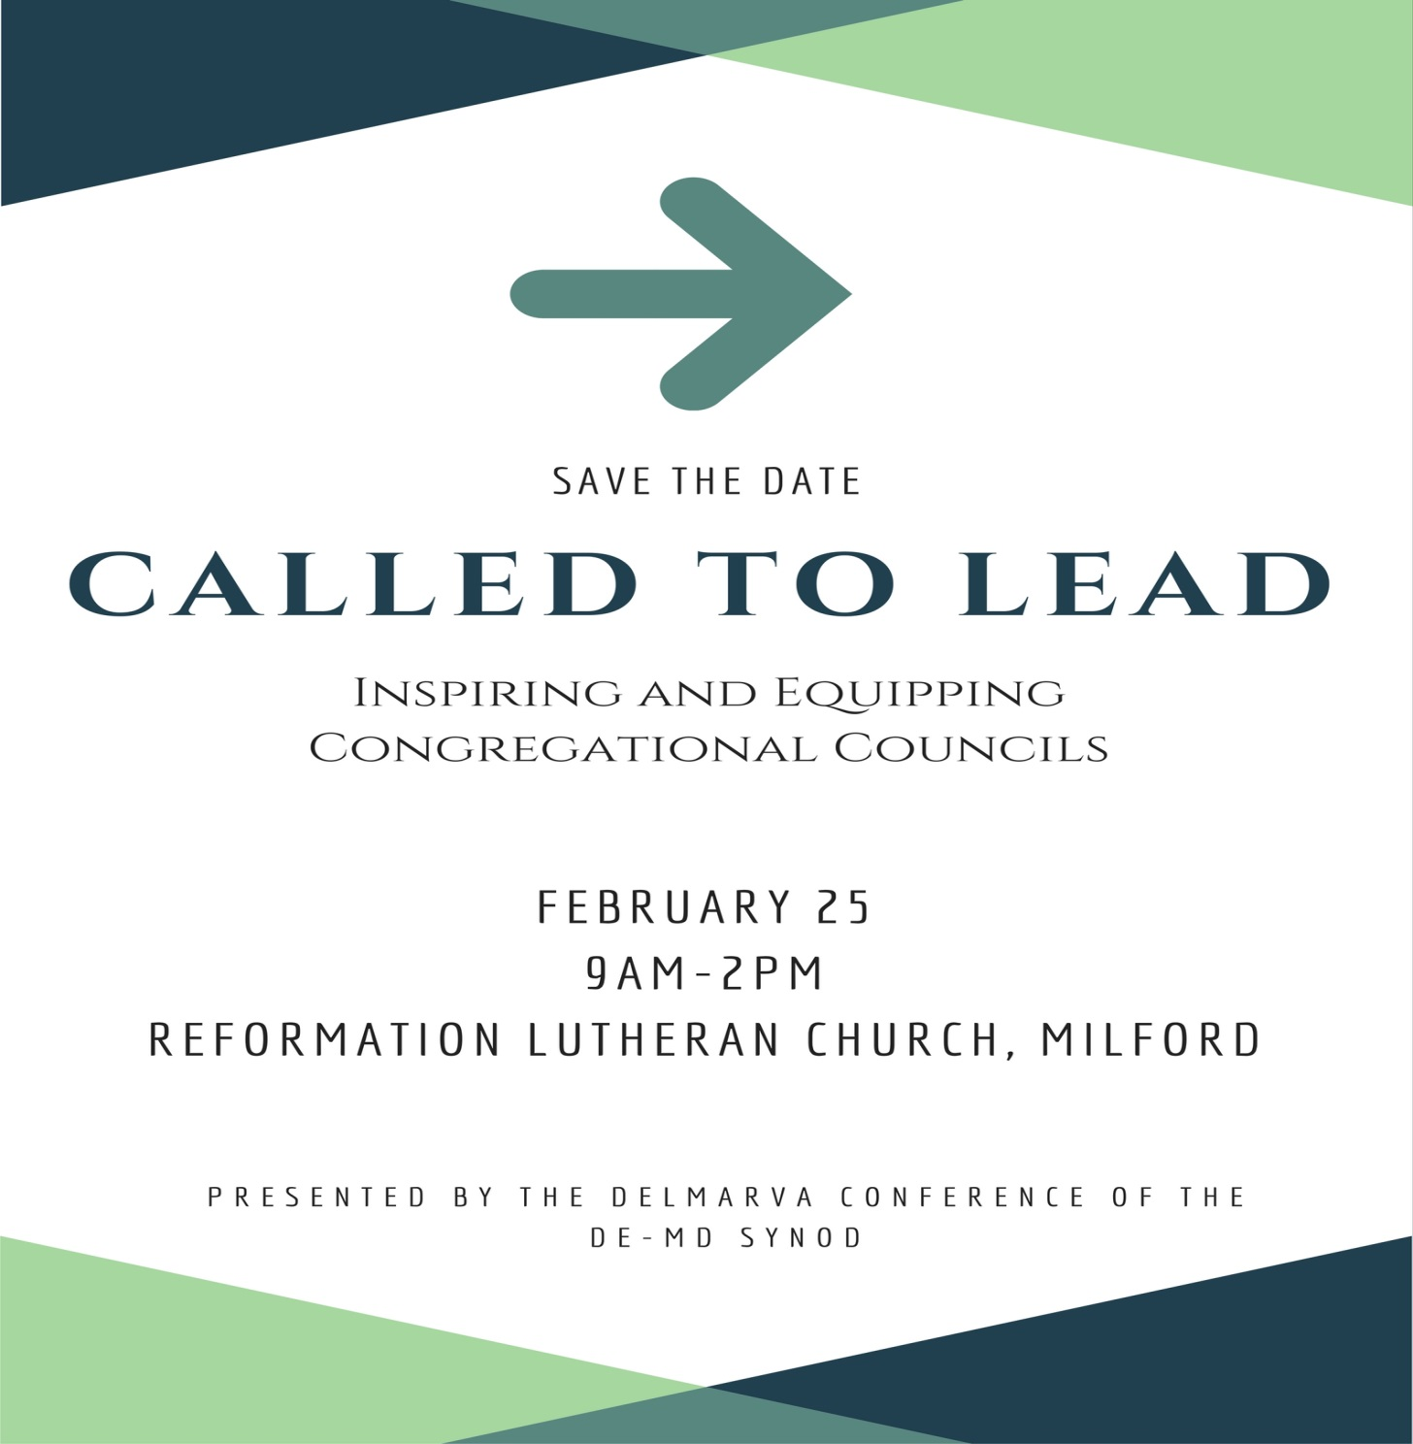

(Thank you clip art?)
Thank you to all who gave of their time and talent in 2016! We worked hard and did some great ministry, and we can do even more for our neighbors in 2017!

Dear friends,
Thank you so much for your generosity to me and my family all year long, and for the Christmas gift you gave me on Christmas Eve. It is so very much appreciated as we begin a time of transition as Luke finishes his schooling (for now!). You all are in my prayers as we begin this new calendar year and we start to do even more ministry together.
Thank you for all that you do.
Peace,
Pastor Kelly

Other ways to give:
(Put in about faithstreet and amazon smile)

Called to Lead, a leadership event for congregations in Delmarva
The Delmarva Conference is presenting another leadership event on February 25 from 9-2pm at Reformation Lutheran in Milford. Lunch is included and the cost will be $15.
All are encouraged to attend to learn more about how to be a leader in our congregation!

