Words of Grace
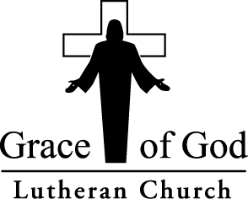
Loving God, living our faith, welcoming all...  and having a good time doing it. | March/April 2017

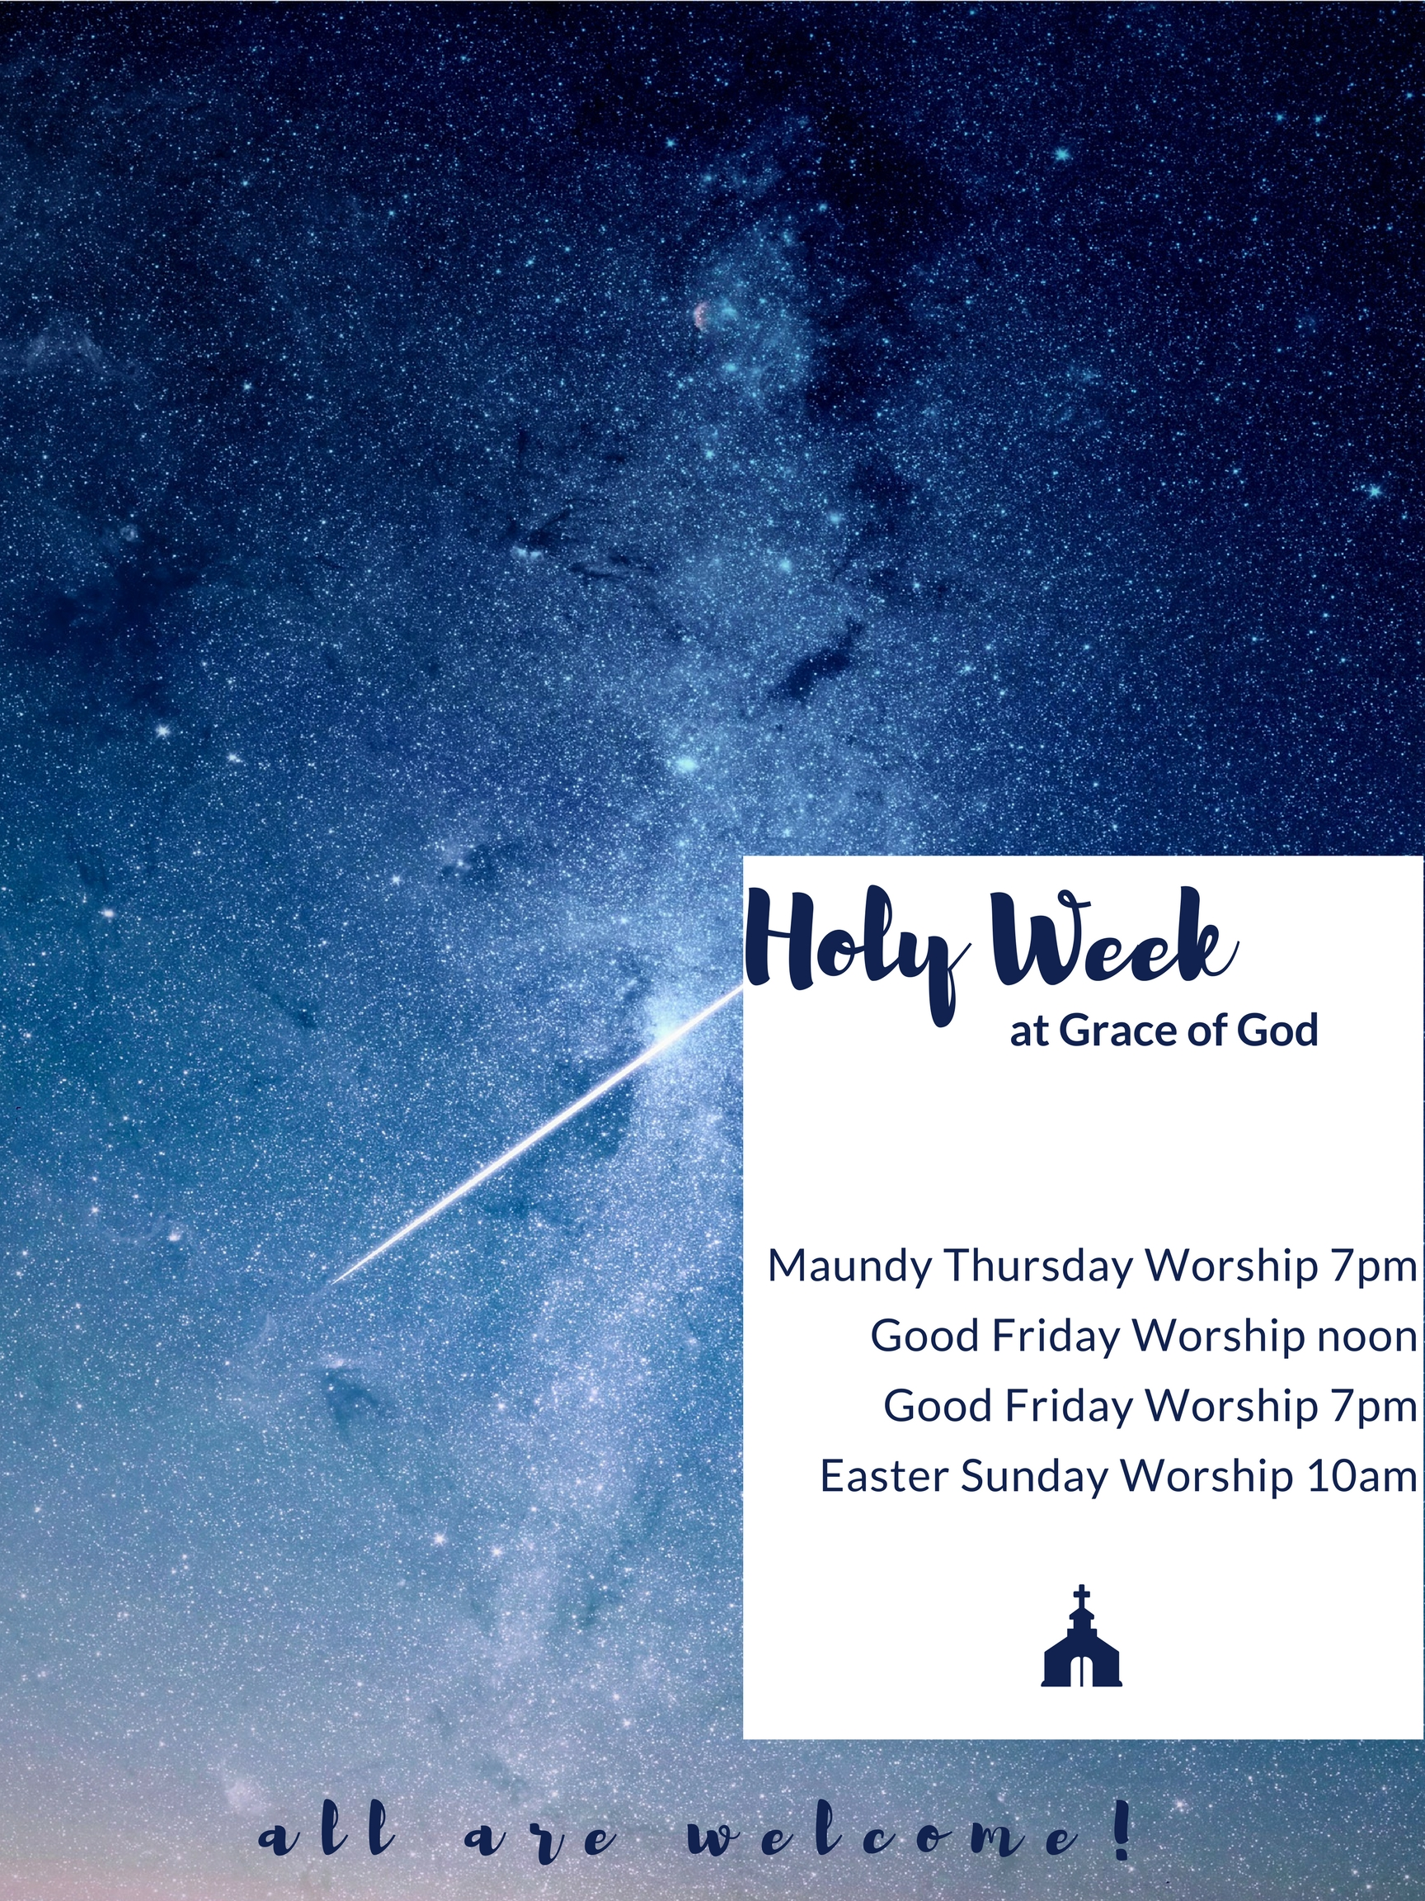
Council and Ministry Updates:
Greetings from your Church Council:

At our recent Annual meeting, based on Council recommendations, we voted to make a difficult and painful decision regarding the land that was purchased during better times. We also approved a new budget that reduces spending to very frugal levels. Everyone on the Congregational Council deeply appreciates the near unanimous support from Grace of God members in making these difficult choices.

It is fitting during this season of renewal that a new Council will soon begin work on a new direction and future for our church. With guidance from God and our prayers and support, they will succeed and find the best path forward. And, we will “have a good time doing it.”

Best wishes for a blessed and happy Easter from your Church Council

Please Welcome New Council Members: Steve Rzonca, President; Frances Kinder, Vice-President; Elmer Brumly, Secretary; Theda Blackwelder; Sue Petersen

Finance Committee:
 | FINANCIAL REPORT
 | January 2017
 |  | Actual | Budget | Variance
 | Income | $11,437 | $9,817 | $1,620
 | Expense | $10,344 | $10,933 | -$589
 | Difference | $1,093 | -$1,116
 | Income exceeded budget and expenses were below budget, providing an overall favorable income to expense surplus of $1093 for the month. This is a great start for the new year!
Thank you for your support of GOGLC!

Community Care:
Have you made decisions about your healthcare and how you would like to be treated? ADVANCE HEALTHCARE DIRECTIVES; Your Right to Decide about Your Health Care forms are available in the office. This informative packet provides you with answers to many healthcare questions you may have. There is also an Advance Healthcare Directive Form and a Power of Attorney for Healthcare Form included for you to complete should you not already have one.

Holy Ground

Holy Ground begins on Tuesday, March 7th. Please plan to join us during Lent for Dinner Church at 6PM. We are looking for volunteers to cook. If you are willing to make a potluck dish for one of the Tuesdays, beginning on March 14th, please sign up on that week’s sheet on the back table on Sunday mornings.

WALKING TO WITTENBERG
WE MADE IT HOME!!
We made it home from Wittenberg. We walked, ran, and biked each day. It was truly an inspirational journey.
OUR MILEAGE TOTAL: 8,253.4



Choir meets every Sunday from
9-9:30 AM. All voices and talents are welcome to join at any time!



Please join us January 26th and February 23rd at 10AM@The Ocean Grill for good food and great discussion!

March Book –The Royal Nanny by Karen Harper

April Book – The Nightingale by Kristin Hannah

GOG EVENTS
- BIBLE STUDY:
Monday morning Bible Study at 11AM at Ocean Grill We are discussing texts and readings for the upcoming Sunday.

Monday night Bible Study at 7PM at Ocean Grill. We will be studying the book of Romans.

- COFFEE WITH PASTOR KELLY:
Need coffee in the morning! Why not spend it with Pastor Kelly every Monday morning at 9AM at Panera Bread.

- GOG BACK IN THE BLACK:
Our noisy offering event in February netted $60.56 for Grace of God.

- LENTEN ADULT CATECHISM STUDY:
Beginning Friday, March 3rd, Pr. Mark Molter and Pr. Kelly will lead a joint “Lenten Adult Catechism Study” with Community Lutheran Church. All are welcome to join us on Fridays at 10AM at the Country Kitchen in Millsboro to dive deeper into Luther’s small catechism.

- SOMETHING TO LOOK FORWARD TO:
I Know a Man … Ashley Bryan, a film by Richard Kane and Robert Shetterly, is a story about a beloved 93-year old artist who skips and jumps in his heart like a child, yet is a spiritually deep creative genius. Ashley has been using art his whole life to celebrate joy, explore the mysteries of faith, and create loving community. His life story and the art he makes are an inspiration to people of all ages.
Your Parish Life Ministry will be bringing this video to you to see and enjoy on an upcoming Sunday, date to be determined, following service. We’ll have a potluck, share a meal, and watch the story of this fascinating man who says, “I try to relate to the inner child in everyone I meet. It’s one thing we all have in common.”

- BIBLE BOOK FAIR:
Looking for a new Bible? Interested in trying a new translation? Curious about trying Bible Journaling? Grace of God will hold a Lenten Bible Book fair starting Sunday, March 19th. Different options of translations, page set ups, and even one that reads like a novel will be available for order. Please pay when you order (checks payable to Grace of God), and the Bibles should be available for pick up in April. Please see Pastor Kelly with any questions.

- MINISTRY SUPPORT:
Our current copier is not functioning properly. Council, working alongside our finance committee and church administrative assistant, Vivian, have explored different companies and collected quotes. The council would like to lease a new machine. Through the second offering already collected, we have a year’s worth of lease payments without having to change the budget or pull from our reserves. We will continue to collect a second offering, and invite you to continue to prayerfully give to that in order to better support our ministry through the copying that supports our worship. Thank you to all who have given so far!

Hidden Inheritance: Imagine discovering a secret—that your family has a hidden Jewish heritage. That your grandfather died in a concentration camp and your grandmother was a death-camp survivor. How did you not know? How would it change your spiritual life? Heidi Neumark, a Lutheran pastor, happened upon records that revealed her family’s loss and trauma and resulted in the shocking revelation that she was suddenly and inherently connected to the multi-ethnic, marginalized community she had been ministering to for three decades and to which she felt a deep affinity. Hidden Inheritance is a combination of a compelling personal story and bold call for social justice that links the past with contemporary challenges. This presentation will be on April 22, 10am-1pm at Hope Lutheran, 230 Christiana Road, New Castle, DE. The Delmarva Conference, in commemorating the Reformation 500, presents a day with Rev. Neumark. The Author will speak and sign copies of her book. Lunch will be provided, and a free will offering will be collected to offset the cost.

All are welcome, please RSVP to lunch (Barbara Malosh, bmalosh@gmail.com)

 Grace of God’s Facebook Page

Keep up to date with what’s happening in the congregation by ‘liking’ our facebook page!
facebook.com/goglc.org

Receive weekly Church news updates by email with our GoG Enews.

To sign up, go to our website (goglc.org) and fill out the form at the bottom of our home page. You will automatically start receiving the enews each week.

Good Search
You Search or Shop…
We Give
Other ways to Give to Grace of God: Use www.Goodsearch.com as your search engine, choose Grace of God Lutheran Church and our church will receive a donation every single time you search (for anything!)

Shop online at goodshop.com, choose Grace of God, and a percentage of each purchase will be donated to our congregation! More than 2,000 top stores are participating including Target, Staples, Best Buy and more!
If you shop on amazon, start at smile.amazon.com and choose Grace of God. Each time you buy a qualifying purchase a percentage of what you spend will come to GoG (at no extra cost to you!).
Start giving electronically. It can be drafted out of your account or put on a card at a specified time each month. It helps us plan our budget and saves you from writing a check (it also is good stewardship of the environment to save paper from checks and envelopes!). Go to our website, goglc.org, or our facebook page and click the Give Online button to get started.

FAITHSTREET GIVING: Make giving to Grace of God easier, never miss a chance to support our ministry (even when you're traveling or miss a Sunday), and save a tree (no envelope needed!). Electronic giving helps you to give joyfully, generously, and intentionally. It helps us to plan for more ministry when we have recurring giving, and it helps you by having to write less checks. Please consider this form of giving. It is simple to set up, just go to our website or facebook page and click the green "give online" button.



CALLING ALL VOLUNTEERS: As we start this new year, what are some new ways you can use your God given gifts or time to better serve God? If you would like to volunteer or hear more about any of these opportunities, please speak with Pastor Kelly. If you have a new idea for a ministry, Pastor Kelly would love to hear it, we’re always looking for new and innovative ways to serve others!
Stewardship Team (Help to talk about how we can be better stewards of our time, money, and spirit given gifts. The stewardship committee encourages others to think about why we give to the church.)
Finance Team (follows the trends of the giving and spending of Grace of God. The finance committee informs the council about what these trends are and presents the information to others leaders of the congregation.)
Holy Ground Coordinator (Coordinate the volunteers so that someone has always signed up for the meal on Tuesday nights. This position is not always the one who cooks!)
Congregational Council (Lead the congregation through attending and participating in worship and ministry. Be present in congregation life and help to discern and fulfill the mission and vision set forth by the congregation.)
Christian Education (Take the children attending worship to the library during the sermon to read a story, do an activity, and/or talk to them about Jesus. This is a position that can rotate so it would only be your responsibility once every few weeks)
Assisting Minister (Be a part of leading the worship of the congregation. This position involves reading, praying, and helping to serve communion)
Greeters/Ushers (Greet those who come in for worship, distribute bulletins, receive the offering, and lead the movement during communion)


Grocery Club Volunteers: Our grocery club wait list continues to grow, and we are losing some volunteers that make it run smoothly. If you are available on the 3rd Wednesday of each month (at the American Legion Post 28), and could give a couple hours, please come. We start set up around 1:30 and there are jobs for all. Join us for this important ministry.

Annual Meeting Outcome

At our congregation’s annual meeting in February new council members were elected, the proposed 2017 budget was passed, and a vote was taken on what to do with the land we have through the Mission Investment Fund (MIF).

In a 30-7 vote, the congregation decided to give up the land to MIF. This means that we no longer will be paying into the loan we had with MIF, and that all funds that were previously given to MIF will be lost. This was a hard and emotional decision for Grace of God, but with our financial realities at this time, it was the decision that will let GoG continue to focus on the ministries we do to help those in our community.

This decision will not affect our future ability to borrow money for another piece of land, but we will not be able to do it through MIF.

What is the Mission Investment Fund (MIF)?

The Mission Investment Fund (MIF) is a ministry of the ELCA that makes loans to ELCA congregations and related ministries for capital building projects and land purchases. The fund finances the loans through the sale of investments to ELCA congregations and their members, synods, and ELCA-related ministries.

MIF is not a part of our synod, but a ministry of the ELCA.

Assisting Ministers – Schedule

3/5 Emilie Crosser
3/12 Bill Davenport
3/19 Lori Dewald
3/26 Iris Fisher
4/2 Marilyn McMahon
4/9 Ellen Roe
4/16 Steve Rzonca
4/23 Theda Blackwelder

Greeters/ Usher – Schedule

3/5 Bill & Janet Davenport
3/12 Barbara Welsh & Beverly Russell
3/19 Kevin & Gail Steward
3/26 Larry & Cheri Belluzzo
4/2 Don & Ellen Roe
4/9 Lou & Donna Gerth
4/16 Dave & Vicki Root
4/23 Alan & Carole Wentworth
4/30 Bill & Janet Davenport

Happy Birthday


3/8 Barbara Welsh
3/15 Linda Lewis
3/19 Margo Ranney
3/22 Fred Gibbs
3/24 Lillian O’Neill
3/27 Kevin Steward
3/29 Jane Moser
3/29 Judi Nulton
3/30 Luan Mundell
3/31 Carol Brumley



4/10 Ed Fairbee
4/19 Elmer Brumley
4/20 Dianne Scott
4/27 Karyl Ritter
4/28 Jerry Mundell

Dates to Remember:

Grace of God

Lutheran Church
P. O. Box 1251
Millsboro, DE 19966
302-947-1044
gogluth1@yahoo.com
Website: GOGLC.org

The Rev. Kelly Pensinger
Vivian Schroeder, Newsletter Editor

Worship: 10:00AM
(Nursery Provided)
Long Neck CHEER Center

Office Hours:
Tues., Wed., Thurs., 9:00 AM - 12:00 PM
At the Long Neck CHEER Center
Millsboro, DE 19966
Mar 20: Spring Begins
Mar 21: Vision Team 4:30 p.m.
Mar 23: Book Group

Apr 5: Parish Life
Apr 9: Palm Sunday
Apr 12: Grocery Club
Apr 13: Council Mtg. 4:30 p.m.
Apr 13: Maundy Thursday Worship, 7 p.m.
Apr 14: Good Friday Worship, 12:00 p.m.
Apr 14: Good Friday Worship, 7 p.m
Apr 15: Blessing of the Animals, 10 a.m.
Apr 16: Easter Sunday
Apr 27: Book Group

