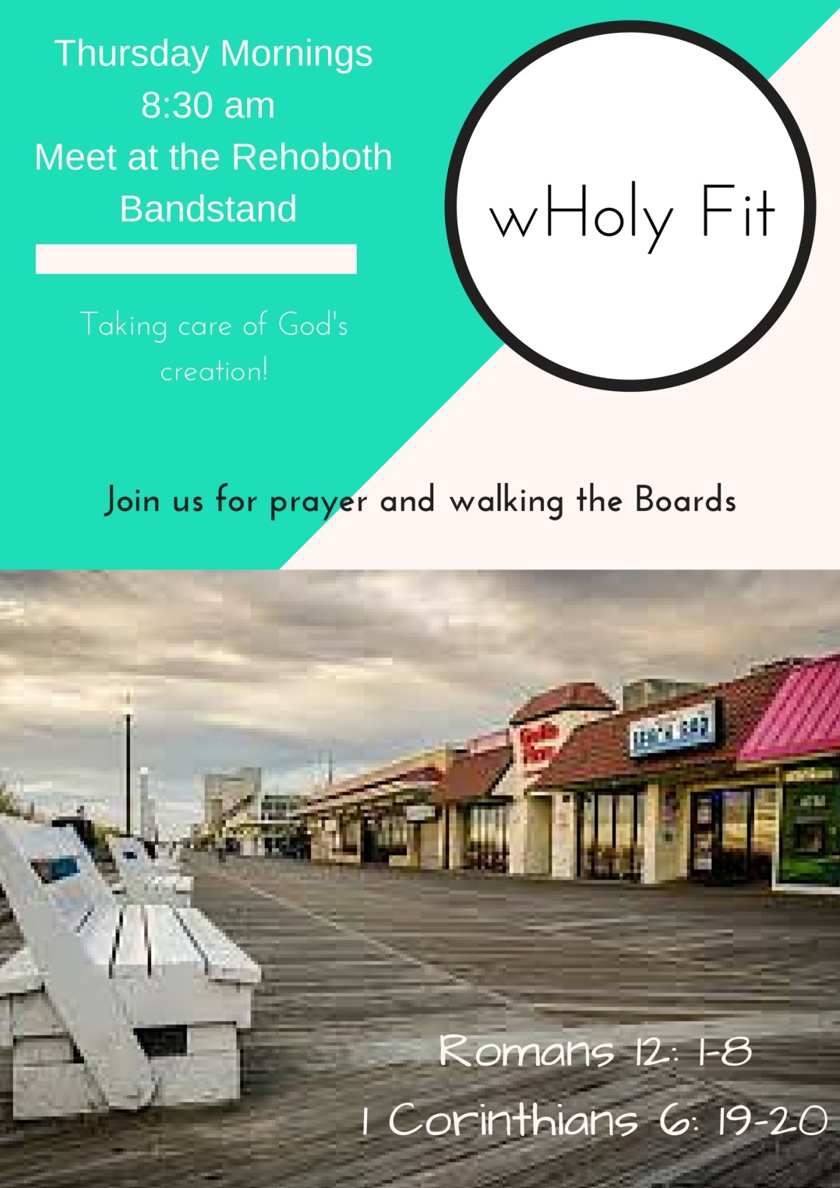

Book group:
A Piece of the World by Christina Baker Kline

Follow the River by Alexander Thom

(Book group for May only will start at 9am. In June it will resume it’s normal 10am time)

Thank you to all who made our Lent, Holy Week, and Easter Celebration possible.

Thank you to all who attended the adult catechism study, asked honest and tough questions, and were open to interpreting our faith in new and exciting ways.
Thank you to those who folded bulletins, Greeted those coming to worship, and who kept the worships running smoothly.
Thank you to those who read our ancient scripture aloud, those who held the wine during communion, who read aloud the prayers for our community and our world, and those who prepared the altar.
A special thank you to our music director Alan Benke for his music leadership and to those who lent their voices to lead us in worshiping God.
And thank you to all who attended the multiple services. I hope that they were rich and meaningful to you as we made our way to the cross, and then finally to the joyous resurrection of our Lord!
+ Pastor Kelly

